 Assignment Cover Sheet

Student Information (For group assignment, please state names of all members) |  | Grade/Marks
Name | ID
Sukriya KC | E2300583
Prashant Thapa | E2300564

Module/Subject Information |  | Office Acknowledgement
Module/Subject Code | BIT 216
Module/Subject Name | Software Engineering Principles
Lecturer/Tutor/Facilitator | Sudeep lal Bjaimaya
Due Date | 26 June 2026
Assignment Title/Topic | SavePlate — Smart Food Waste Reduction Web Application
Intake (where applicable) | Nov,2023
Word Count |  | Date/Time

Declaration
- I/We have read and understood the Programme Handbook that explains on plagiarism, and I/we testify that, unless otherwise acknowledged, the work submitted herein is entirely my/our own.
- I/We declare that no part of this assignment has been written for me/us by any other person(s) except where such collaboration has been authorized by the lecturer concerned.
- I/We authorize the University to test any work submitted by me/us, using text comparison software, for instances of plagiarism. I/We understand this will involve the University or its contractors copying my/our work and storing it on a database to be used in future to test work submitted by others.
Note: 1) The attachment of this statement on any electronically submitted assignments will be deemed to have the same authority as a signed statement.
2) The Group Leader signs the declaration on behalf of all members.

Signature: Prashant Thapa | Date:26 june,2026
E-mail: prashant.thapa23@midvalley.edu.np

Feedback/Comments*
Main Strengths
Main Weaknesses
Suggestions for improvement

 | Student acknowledge feedback/comments
Grader’s signature | Student’s signature:
Date: | Date:
Note:
- A soft and hard copy of the assignment shall be submitted.
- The signed copy of the assignment cover sheet shall be retained by the marker.
- If the Turnitin report is required, students have to submit it with the assignment. However, departments may allow students up to THREE (3) working days after submission of the assignment to submit the Turnitin report. The assignment shall only be marked upon the submission of the Turnitin report.

*Use additional sheets if required.

Functional and Non-Functional Requirements
The functional requirements are the behaviours, features, and functions that the SavePlate web application must have. Non-functional requirements are the quality attributes and performance requirements that the system must possess to ensure reliable and satisfactory user experience.

1.1 Functional Requirements
ID | Use Case | Functional Requirement
FR01 | User Registration & Privacy Settings | The system shall provide the capability to new user(s) to Register/Set Privacy Settings by providing full name, email address, and password
FR02 | User Registration & Privacy Settings | The system will perform validation of the user's data while registering and will provide feedback to the user if the data provided for registration is invalid or incomplete.
FR03 | User Registration & Privacy Settings | The system will enable the registered users to log in by their user id and Password.
FR04 | User Registration & Privacy Settings | The system should allow the user to turn on or off two-factor authentication (2FA) for the user's account.
FR05 | User Registration & Privacy Settings | The system shall give the user the ability to set account privacy settings – show/hide profile – show/hide donation lists
FR06 | Manage Food Inventory | The system should enable them to add a new food item to their household inventory, providing data about the item such as its name, quantity, expiration date, category, and storage location.
FR07 | Manage Food Inventory | The system shall enable users to be able to edit the information of foods in their inventory.
FR08 | Manage Food Inventory | The system shall allow users to delete food items from their inventory
FR09 | Manage Food Inventory | Food items in the system shall be automatically alerted if they are about to expire.
FR10 | Manage Food Inventory | Food items in the system shall be automatically alerted if they are about to expire.
FR11 | Browse Food Items | The system shall print a list of food donation listings by other households available for pick up.
FR12 | Browse Food Items | The system shall enable users to sort the list of food items they want to donate by location, type of food, and the date the food is expected to expire.
FR13 | Browse Food Items | The system shall enable the user to claim a listing of food items and notify him or her of the successful claim.
FR14 | Food Analytics | The system shall not allow users to take their own donation listings.
FR15 | Food Analytics | The system will create visual food-saving, food-donation, and food-waste reports for the user
FR16 | Food Analytics | The system should enable users to see their food analytics for flexible periods of time: weekly, monthly, custom dates
FR17 | Food Analytics | The system shall provide visual feedback of progress indicators of the total number of food items saved, donated, and wasted by the user.

1.2 Non-Functional Requirements
ID | Category | Non-Functional Requirements
NFR101 | Performance | Under normal network conditions, any page shall be loaded within 3 seconds.
NFR102 | Performance | The system will support simultaneous access by multiple users to the platform, without performance degradation.
NFR103 | Security | User passwords stored in the database shall be encrypted with industry standard hashing algorithms by NFR03SecurityAll.
NFR104 | Security | The system shall establish session management that will automatically log inactive users after a certain amount of time.
NFR105 | Security | All communications between the client and the server will be encrypted using the HTTPS protocol in order to avoid any possibility of unauthorized access to the data.
NFR106 | Usability | The system shall have a clean, intuitive and user friendly interface which does not require any technical expertise to operate.
NFR107 | Usability | The system shall provide informative and explanatory error messages to help with failed actions and invalid inputs
NFR108 | Reliability | The system shall be up to at least 95% during demonstration and testing period.
NFR109 | Compatibility | The system must be compatible and fully functional with the most popular current Web browsers such as Google Chrome and Mozilla Firefox
NFR10 | Compatibility | The system shall be responsive and accessible on screens with varying resolutions, such as the resolution of the laptop or desktop screen.
NFR11 | Maintainability | The system's source code shall be well structured, commented and version controlled using the GitHub system, to support future maintenance and updates.

- Epics, Users Stories, Acceptance Criteria and Tasks

UC1: Register User & Privacy Settings
Epic:
As a first time user of Save Plate, I want to have the ability to: Register for an account, enable authentication and control my privacy settings so that I can safely and confidently use SavePlate to manage my household food inventory.

User Story 1.1:

User registration form: I need to register an account, using my personal data, so I can use the SavePlate Platform and its features for the first time as a new user.

MoSCoW Priority: Must have

Acceptance Criteria:
# | Given | When | Then
AC1 | The user is at Registration Page. | He/she types his/her name, e email and password and then clicks on Register button. He/she types his/her name, e-mail and password and then clicks the Register button. | He/she types his/her name, e-mail and password and then clicks the Register button.
AC2 | Currently you are on the registration page. | User fills in the form and uses his already registered email address. | An error message is displayed in the system that the email is in use.
AC3 | You are on the Registration page at the moment. | The user fills out the form with missing or bad information. | The system identifies the invalid fields and provides relevant error message.

Tasks:
# | Task | Assigned To
T1 | Create UI for registration form using React.js | Sukriya
T2 | Add form validation for all form fields. | Sukriya
T3 | Develop the user registration API in Node.js | Sukriya
T4 | Use bcrypt for password hashing before storing in MySQL .Run bcrypt on the passwords before storing in MySQL. | Sukriya
T5 | Test registration with valid and invalid inputs. | Sukriya

User Story 1.2-User login
User Story:

MoSCoW Priority: Must have

Acceptance Criteria:

# | Given | When | Then
AC1 | The user logs in to the system. | The user provides a valid email and password and clicks on login | The system verifies the user and takes the user to his dashboard
AC2 | The user logs in. | The user enters an email or password that is not correct | The system shows an error message, saying that the email/password entered is not valid
AC3 | No email or password is typed into the log-in boxes and the user clicks the Login button. | If the user leaves either the email or the password blank, and clicks on the Login button. | A validation error message is shown in the system that the user needs to fill in all of the required details.

Tasks:
# | Task | Assigned To
T1 | Create UI for the login form using react.js. | Sukriya
T2 | Add form validation to the logins. | Sukriya
T3 | Generate the login API endpoint that generates a session token. | Sukriya
T4 | Add session management, and redirect functionality. | Sukriya
T5 | Spam login using valid, invalid and empty credentials | Sukriya

User story 1.3-Two Factor Authentication (2FA)

User story: As a registered user, I have to activate two-factor authentication on my account, in order to add an additional security layer to safeguard my personal data.
MoSCoW Priority : Could Have

Acceptance Criteria:

# | Given | When | Then
AC1 | ` | The system supports 2FA and provides a verification code to the user's registered e-mail. | The system supports 2FA and provides a verification code to the user's registered e-mail.
AC2 | The user has 2FA enabled and tries to log in. | The user provides email and password. | The user is required to enter the verification code sent to their email address, prior to gaining access to their account.
AC3 | The user has turned on 2FA but typed in the wrong verification code. | Upon pressing the Verify button, | They are greeted with an error message on the computer screen that says that the code they entered is incorrect and they are asked to enter again.

Tasks:
# | Task | Assigned To
T1 | Implement 2FA settings UI using React.js | Sukriya
T2 | Add a toggle for 2FA to the security settings toggle. | Sukriya
T3 | Incorporate code generation and sending for email verification' | Sukriya
T4 |  | Sukriya
T5 | 2FA enable, disable and verification flows will be tested. Enable, disable and verification 2FA flows will be tested. | Sukriya

User story 1.4- Privacy Settings:
User Story: User Story: As a registered user I want to be in control of who can access my account information and see some of my information on the platform.
MoSCoW Priority: Could Have

Acceptance Criteria:

# | Given | When | Then
AC1 | User is on the privacy page. | The user makes his/her profile private and saves it. | The system updates the privacy settings and user's profile is hidden for the other users.
AC2 | The user is on the privacy settings page. | User makes the donation list private and saves. | The system resets the settings and makes the user's donations not appear in the browse page.
AC3 | The user is on the Privacy settings page. | User stores their privacy settings. | A success message appears, stating that the settings have been updated.

Tasks:
# | Task | Assigned To
T1 | Create UI for privacy settings in React. Js Person | Sukriya
T2 |  | Sukriya
T3 | Create API endpoint to update and get privacy settings Person | Sukriya
T4 | Implement conditional rendering based on privacy settings throughout the platform Person | Sukriya
T5 | Displays a list of possible privacy settings and allows you to choose one of them.List and lets you select one of Test's privacy settings. | Sukriya

UC2: Manage Food Inventory:
Epic:
I want to be able to add, edit and delete food items in my household inventory, track their expiry dates and mark them as "Donate" when they are close to their expiry date to manage my food supplies and reduce unnecessary food waste.

User story 2.1-Add Food Item
User story:
A registered user should add new food products to their household inventory listing with specific information, to maintain an up-to-date and accurate inventory of the products available in the household.

MoSCoW Priority: Could Have

Acceptance Criteria:

# | Given | When | Then
AC1 | You are on the inventory page of the app. | The user enters in the name of the item, number of items, due date for use, item classification, and item location, and then clicks Add Item. | The new food item is stored into the system and shows in the inventory listAC2User is on the add item form.
AC2 | The user is on the Add Item Form. | The user fills out the form but fails to fill in some required fields. | The empty cells are highlighted and the proper error messages are shown.
AC3 | The user is on the Add Item Form. | The user is entering an expired date. An expired date is being entered. | This will alert the user to the warning which the system displays if the item is already expired.
Tasks:

# | Task | Assigned To
T1 | Develop the “Add Food Item” form UI using React.js. | Prashant
T2 | Use forms to validate required fields. | Prashant
T3 | Built the add food item API endpoint in Node.js. | Prashant
T4 | Save the information about the food item to MySQL database | Prashant
T5 | Test adding foods when the food added is valid, invalid, or missing. | Prashant

User story 2.2-Edit Food Items
User Story: I'm a registered user, and I need to edit the details of an already existing food item in my inventory, so that I can maintain my inventory with an accuracy and timely update if there are any changes in quantity or details.
MoSCoW Priority: Could Have

Acceptance Criteria:

# | Given | When | Then
AC1 | This user is on the inventory page. | The user clicks the Edit button of a food item and edits the details | The system saves the updated details and updates the inventory list.
AC2 | The user is working on a food item. | The user submits the form with missing required fields. | The validation of the system is failing, and the change cannot be saved.
AC3 | The user is working on a food item. | The user changes the expiry date to a future date and saves. | The system changes the expiry date and previous expiry warning for that item is removed.

Tasks:
# | Task | Assigned To
T1 | Create the UI for the edit food item form in React.js | Prashant
T2 | Fill in the edit form with the existing item information | Prashant
T3 | Create the edit food item API endpoint in Node.js | Prashant
T4 | Add the food item to the database | Prashant
T5 | Test with valid, invalid and not changed food items as input for editing. | Prashant

User Story 2.3-Delete Food Item
User Story:
Being a registered user, I would want to remove a food item from the inventory, so I can remove what has been eaten, disposed, or irrelevant.

MoSCoW Priority: Could Have
Acceptance Criteria:

# | Given | When | Then
AC1 | You are on the user's inventory page. | The user clicks the Delete button of a food item and clicks OK | The item will be permanently deleted from the inventory and the inventory list will be updated.
AC2 | The user is on inventory page. | User clicks a food item's Delete button. | You will receive a warning box which will ask you if you are sure you want to delete the record.
AC3 | The delete confirmation is cancelled by the user. | The user presses Cancel to cancel the deletion. | The prompt is dismissed and the food item is still in the inventory.

Tasks:

# | Task | Assigned To
T1 | Add delete button and confirmation prompt in UI using React.js. | Prashant
T2 | Create the delete food item API endpoint in Node.js | Prashant
T3 | Delete the food item from the MySQL database. | Prashant
T4 | Update the list of items displayed once they have been deleted. | Prashant
T5 | Test deleting and deleting with confirmation/cancellation. | Prashant

User story 2.4-Expiry Date Tracking and Donation Flagging

User story:
As a registered user, I want the system to automatically track foods' expiry dates and let me mark food that is near its expiry date for donation so I can take action in a timely manner before the food becomes wasted.

MoScOW Priority: Must have

Acceptance Criteria:

# | Given | When | Then
AC1 | Within 3 days of the food item's expiry date. | Sets the “near expiry” reminder on the item in the inventory list automatically. | The user will be able to view an item in their inventory that is about to expire.
AC2 | An item will be visible to the user in their inventory that is about to expire. | The user presses the Flag for Donation button of the item | The system notifies it for donation and generates a donation list that can be seen on the browse page.
AC3 | The user marks an object to be donated. | The item has been properly posted as a donation. | A success message is shown, stating that the item has been listed for donation.

Tasks:
# | Task | Assigned To
T1 | Put into practice expiry date monitoring logic to mark items within 3 days of expiry. | Prashant
T2 | Create a UI for approaching out of stock alert. | Prashant
T3 | Person BT3Implement the Flag for Donation button and its functionality. | Prashant
T4 | Develop API endpoint for turning a flagged item into a donation listing. | Prashant
T5 | Track expiry of tests with different expiry date scenarios and track as to whether items have been donated or not. | Prashant

UC3: Browse Food Items

Epic: I need to be able to use the SavePlate so that I can view the food donation listings of other households that are registered to use SavePlate, filter household food donation items based on my preferences and claim items that I need; so that I can reduce the food waste in my community by using surplus food that would otherwise be discarded.

User story 3.1-View Donation Listings
User story:
I should see a list of the food donation listings posted by other users who are registered in my area as a registered user, so I can see what food items I can claim in my area.
MoSCoW Priority: Must Have
Acceptance Criteria:
# | Given | When | Then
AC1 | The user is logged in and is taken to the Browse page. | The page loads | The system shows all the food listings for donation with item name, category, expiry date and location.
AC2 | The user is on the Browse page | There are no available donation listings | The following message is shown in the system: "No listings at this time.
AC3 | The user is at the "Browse" page. | The page loads | The user's own donation listings are not shown in the browse list of the system.

Tasks:
# | Task | Assigned To
T1 | Create the UI for Browse Food Items page using React.js. | Prashant
T2 | Develop the API that will get all the available donation listings from MySQL database. | Prashant
T3 | Add logic to remove the currently logged in user's listings from the browse list. | Prashant
T4 | Show listing information; name, category, expiry date, location | Prashant
T5 | Test browse page with available listings and NO listings scenarios | Prashant

User story3.2-Filter Donation Listings
User story: As a registered user this is the information I need to be able to filter through to see only food items that are relevant and available to me, by location, food category and expiry date.
MoSCoW Priority: Must Have
Acceptance Criteria:
# | Given | When | Then
AC1 | The user is on the Browse page | The user clicks on a food type from the filter and applies it. | The results of the listing are updated to show only those items that match the selected category.
AC2 | The user is on the Browse page | The user filters the data according to location. | The system only shows donations from households in the area.
AC3 | The user will be on the Browse page | The user applies more than one filter. | Only listings will appear in the system that meet all the filter criteria.

Tasks:
# | Task | Assigned To
T1 | Create a filter UI using React.js | Sukriya
T2 | Add a filter for category, location and expiry date. | Sukriya
T3 | Develop API to get filtered donations lists from MySQL. | Sukriya
T4 | Allow for dynamic re-rendering of listings, when filters are applied or changed. | Sukriya
T5 | Apply single and multiple filter combinations to test filtering. | Sukriya
User Story 3.3-Claim A Food Item
User Story : As a registered user I must take over a food donation that is available for picking up, so that it is not wasted
MoSCoW Priority: Must Have
Acceptance Criteria:
# | Given | When | Then
AC1 | The user is at the Browse page and there is a listing available. | The user clicks on the Claim button. | Once the listing is claimed on the system, it will be taken off the available listings page on the browse page.
AC2 | If the user succeeds, the food item is theirs. | The statement is supported. | The system notifies the claimant and donor that the claim has been successful
AC3 | The user tries to take the listing that is already taken by another user. | The user is currently on the Browse page, and he finds that there is a listing. | f the user has already taken it will display a message to the user.

Tasks:
# | Task | Assigned To
T1 | Add Claim button to all donation listing cards in React.js | Sukriya
T2 | Build the food item API in node.js | Sukriya
T3 | Put claimed in the MySQL listing status column. | Sukriya
T4 | Enforce “confirmation” notification for donor and claimant. | Sukriya
T5 | Test claims in available, claimed and own listing scenarios. | Sukriya
User story3.4-View Listing Details
User Story: Before I pick up an item on a donation, I have to view the full description of that donation listing, a requirement as a registered user.
MoSCoW Priority: Could Have
Acceptance Criteria:
# | Given | When | Then
AC1 | The user is on the Browse page. | The user clicks on one of the donation entries. The user clicks on one of the donation items. | The system takes you to a detailed view of the item which includes the name, description, quantity, expiry date, category, storage location, and pickup details.
AC2 | On the listing detail page. | It hasn't been removed from stock. | There is an active, Claim button on the system that enables the user to claim the item.
AC3 | User is viewing listing details page. | This item is already claimed. | The system will show it as unavailable and it will turn off the Claim button.

Tasks:
# | Task | Assigned To
T1 | Build UI for the listing detail page in React.js | Sukriya
T2 | Develop API endpoint to get complete information about a particular listing. | Sukriya
T3 | Add navigation from browse to listing detail page. | Sukriya
T4 | Show Claim status and conditionally present Claim button, depending on whether it's available. | Sukriya
T5 | Test detail page using available and claimed properties. | Sukriya
UC4: Food Analytics
Epic: I wish to be able to see the visual progress and the drop offs of my food saving, donating and food waste over time so that I can see how I am consuming food and make more informed and responsible choices.
User Story 4.1-View Food Analytics Dashboard
User story: I'm a registered user who should be able to see a food analytics dashboard that provides a summary of the food I have saved and wasted, to give me a quick overview of my overall food management performance.
MoSCoW Priority: Must Have
Acceptance Criteria:

# | Given | When | Then
AC1 | The user logs in and goes to Analytics page. | The page loads | The system shows the user a dashboard that contains visual charts and progress indicators to summarize the user's food-saving, food giving and food waste activities.
AC2 | The user has been taken to the Analytics page. | No recorded activity by the user. | An empty state message is shown, stating that there are no data.
AC3 | The user is on the Analytics page. | The page loads | The system will only show data of the user who has logged in and not the data of other users.

Tasks:
# | Task | Assigned To
T1 | Create UI for the Food Analytics dashboard using React.js. | Prashant
T2 | Write the API end point to get the user's food activity data from MySQL. | Prashant
T3 | Use charts like Chart.js or Recharts to create visual charts that will facilitate the explanation. | Prashant
T4 | Show progress on items saved, donated and wasted totals. | Prashant
T5 | Run the dashboard on actual data and no data scenarios. | Prashant

User Story 4.2-Filter Analytics by Time Period
User story: As a registered user, I want to be able to filter my food analytics based on the time period that I want such as weekly, monthly and custom ranges of dates, so that I can monitor my progress in managing my food over a particular period of time.
MoSCoW Priority: Must Have
Acceptance Criteria:
# | Given | When | Then
AC1 | The user is responding in the Analytics page. | The user clicks on the Weekly filter. | The system is updated to show the data for the week only on the dashboard.
AC2 | The user is on the Analytics page | The user clicks on Monthly filter. | The system filters the data it shows on the dashboard, and only displays that data for the current month.
AC3 | You are on the Analytics page of your user. | User chooses a custom date range and applies it. | The system will update the dashboard with data that is recorded between the date range selected.

Tasks:
# | Task | Assigned To
T1 | Create and use time period filters in UI using React.js. | Prashant
T2 | Implement filter logic for weekly, monthly and custom date range selection. | Prashant
T3 | Develop API to get filtered analytics data by selected time period | Prashant
T4 | Include the ability to dynamically re-render charts and indicators as filters are applied | Prashant
T5 | Test Date Range Filtering by week, month and custom date range, | Prashant
User Story4.3-View Food Waste Report
User Story: I need to access a detailed food waste report as part of being a registered user; this will display the foods I've wasted over a specific period of time, and allow me to look for trends in my food consumption and find ways to decrease my future food waste.
MoSCoW Priority: Should Have
Acceptance Criteria:
# | Given | When | Then
AC1 | You are now on the Analytics page. | The user clicks on Food Waste Report. | The system prints a list of food items which have expired and were not eaten or donated during the given time period
AC2 | The user is now looking at the Food Waste Report. | The report is made with waste items. | Each item wasted is shown with the item name, category, quantity and expiry date.
AC3 | The user is looking at the Food Waste Report. | No waste items in selected period for the user. | If there is no food loss, a positive message is shown in the system and it tells the user that there had been no food loss during the selected time period.
# | Task | Assigned To
T1 | Create the Food Waste Report section UI using React.js | Prashant
T2 | Add logic to determine and log items that are expired and have not been eaten or given away | Prashant
T3 | Develop an API for getting wasted item records from MySQL. | Prashant
T4 | Show waste items with their name, type, amount and expiration date | Prashant
T5 | Test the waste report on trash and empty waste cases. | Prashant
Tasks:

User story 4.4-View Food Saving Progress Indicators
User story: As a registered user, I should be able to see progress indicators to let me know how much food I've saved and donated, to keep me on track to make responsible food choices.
MoSCoW Priority: Could Have
Acceptance Criteria
# | Given | When | Then
AC1 | The user is on the Analytics page | The page loads | The system shows the progress indicators of the total food items that are saved, donated and wasted by the user.
AC2 | The Analytics page is displayed for the user. | The user has donated at least one item | The system shows the total amount of donations that the user has made successfully.
AC3 | The user has gone to the Analytics page. | The number of food items stored by the user is displayed. | The system updates the progress indicator as it is collecting data as it goes.
Tasks:
# | Task | Assigned To
T1 | Design the progress indicators UI components in React.js | Prashant
T2 | Add some logic to calculate the number of items that were saved, donated, and wasted. | Prashant
T3 | Develop an API to fetch progress summary information from MySQL. | Prashant
T4 | Use on-load or real time progress indicators. | Prashant
T5 | evaluate progressors for different levels of user activity | Prashant

Architectural design
This is drawn in draw.io so I will be pasting the screen shot of the architectural design

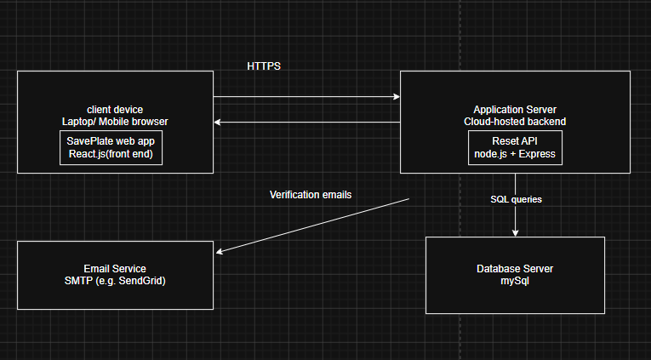

Site map
Below diagram is the site map of the save plate web app
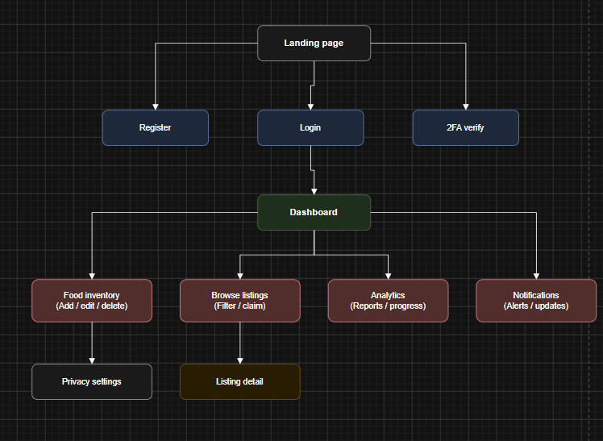

Wireframes of the save plate webapp
- Login page
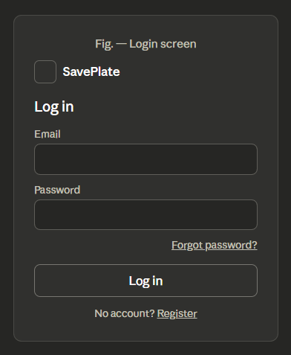
- 2FA verification
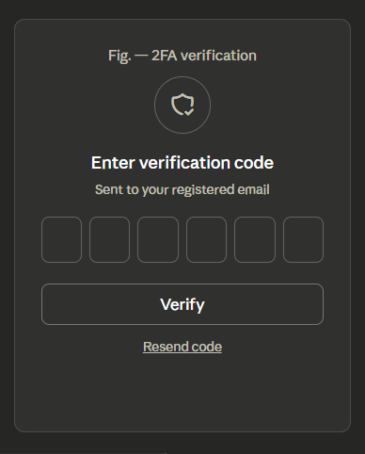

- Registration form
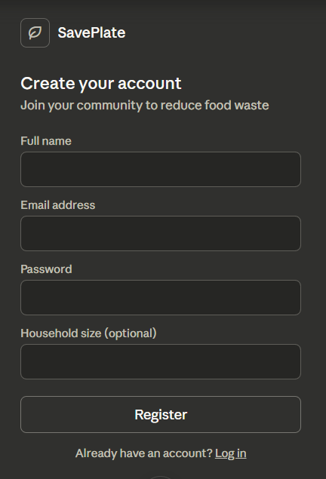

- Privacy Setting
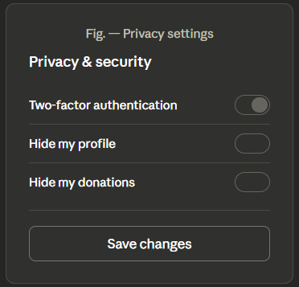

- Browse listing

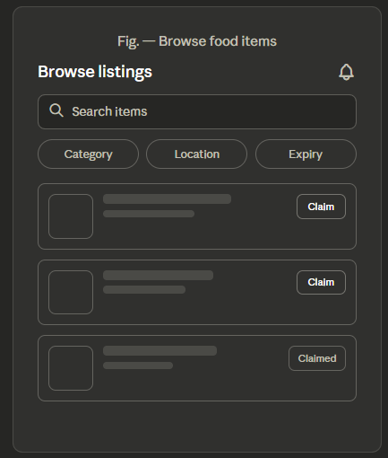

- Listing detail page

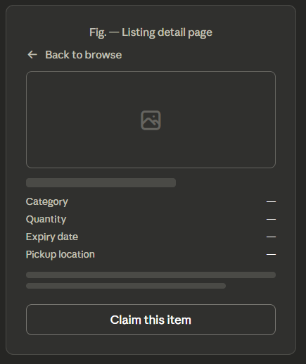

- Food inventory
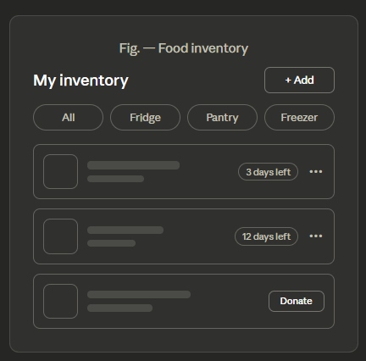

- Food analytics Dashboard
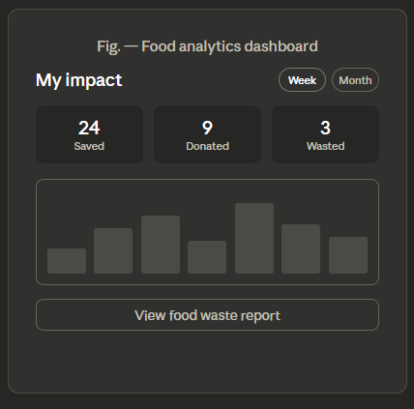

Data Dicretory
Table: USER
Field | Data Type | Constraints | Description
user_id | INT | PK, AUTO_INCREMENT | Unique identifier for each user
full_name | VARCHAR(100) | NOT NULL | User's full name
email | VARCHAR(150) | NOT NULL, UNIQUE | User's email address, used for login
password_hash | VARCHAR(255) | NOT NULL | Bcrypt-hashed password
two_fa_enabled | BOOLEAN | DEFAULT FALSE | Whether 2FA is active for this account
household_size | INT | NULLABLE | Optional household size entered at registration
created_at | DATETIME | DEFAULT CURRENT_TIMESTAMP | Account creation timestamp
Table: PRIVACY_SETTINGS
Field | Data Type | Constraints | Description
settings_id | INT | PK, AUTO_INCREMENT | Unique identifier for settings record
user_id | INT | FK → USER.user_id | Owner of these settings
profile_hidden | BOOLEAN | DEFAULT FALSE | Whether profile is hidden from other users
donations_hidden | BOOLEAN | DEFAULT FALSE | Whether donation listings are hidden
Table: FOOD_ITEM
Field | Data Type | Constraints | Description
item_id | INT | PK, AUTO_INCREMENT | Unique identifier for the food item
user_id | INT | FK → USER.user_id | Owner of the inventory item
item_name | VARCHAR(100) | NOT NULL | Name of the food item
quantity | INT | NOT NULL | Quantity in stock
expiry_date | DATE | NOT NULL | Expiry date used for alerts
category | VARCHAR(50) | NOT NULL | e.g. canned, frozen, fresh
storage_location | VARCHAR(50) | NULLABLE | e.g. fridge, pantry, freezer
status | ENUM('active','used','donated') | DEFAULT 'active' | Current state of the item

Table: DONATION_LISTING
Field | Data Type | Constraints | Description
listing_id | INT | PK, AUTO_INCREMENT | Unique identifier for the listing
item_id | INT | FK → FOOD_ITEM.item_id | Food item the listing is based on
posted_by | INT | FK → USER.user_id | User who created the listing
claimed_by | INT | FK → USER.user_id, NULLABLE | User who claimed the listing (if any)
pickup_location | VARCHAR(150) | NOT NULL | Pickup address or area
listing_status | ENUM('available','claimed') | DEFAULT 'available' | Current listing state
posted_at | DATETIME | DEFAULT CURRENT_TIMESTAMP | When the listing was created
Table: NOTIFICATION
Field | Data Type | Constraints | Description
notification_id | INT | PK, AUTO_INCREMENT | Unique identifier for the notification
user_id | INT | FK → USER.user_id | Recipient of the notification
type | ENUM('expiry','donation','meal_plan','account') | NOT NULL | Notification category
message | VARCHAR(255) | NOT NULL | Notification text content
is_read | BOOLEAN | DEFAULT FALSE | Whether the user has read it
created_at | DATETIME | DEFAULT CURRENT_TIMESTAMP | When the notification was generated

ERD Diagram
Below is the ERD diagram built in draw io.
